Name: _________________ Seat# ___ COSC 3380

HW 1 (to be turned in for grading):
(100 points)
(Due date found in the COSC 3380 Detailed Syllabus!)

Electronic: a Word document to be attached to BB and turned in a as a Hardcopy;

Hardcopy: a handwritten PAPER AND PENCIL!,

WARNING: YOU WILL LOOSE 10 points IF YOU DO NOT MARK YOUR SEAT NUMBER ON THE HARCOPY!

I UNDERSTAND THAT TURNING ANOTHER’s WORK IN is CHEATING.
I UNDERSTAND THAT ANY KIND OF DISSEMINATION of this WORK is CHEATING.

- Electronic Version not attached to BB - 10 points
- No screenshot of the BB attachment - 5 points
- Hardcopy not submitted - 10 points
- Not answered by hand - 10 points

I CERTIFY THAT THE HOMEWORKs SOLUTIONs ARE MY OWN WORK!
SIGNATURE:

BASED on LECTURE 2 DATA MODELING - WHAT - ERD MODEL

1. (10 points) Data Requirements Analysis for ERD (E + H)
(You need to do the Textual Analysis on the Requirements below)

Construct an ERD Model for a car insurance company whose customers own one or more cars each. Customer’s customer_id, name, and address need to be stored in the database. Each car has associated with it zero to any number of recorded accidents. Both car’s licence_no and model data need to be stored in the database. Accident’s report_id, date, and place need to be stored in the database. Each insurance policy (has a policy_id) covers one or more cars, and has one or more premium payments (amount) associated with it. Each payment (has a payment_no) and is for a particular period of time, and has an associated due date, and the date when the payment was received.

ANSWER:

2. (10 points) Data Requirements Analysis for ERD (E + H)
(You need to do the Textual Analysis on the Requirements below)

Consider a database used to record the marks that students get in different exams of different course offerings (sections). Student’s student_id, name, dept_name, and tot_cred need to be stored in the database. Section’s sec_id, semester, and year need to be stored in the database. Course’s course_id, title, and credits need to be stored in the database. Exam’s exam_id, name, place, and time need to be stored in the database.

a. (E + H)
Construct an E- R diagram that models exams as entities, and uses a ternary relationship between student, section, and exam, for the database.

ANSWER:

b. (E + H)
Construct an alternative E- R diagram that uses only a binary relationship between student and section. Make sure that only one relationship exists between a particular student and section pair, yet you can represent the marks that a student gets in different exams.

ANSWER:

BASED on LECTURE 3 DATA MODELING HOW - RELATIONAL MODELS

3. (10 points) (H)

Since Relations are sets and, thus, cannot have identical elements, the set of all attributes in a Relation must be a superkey. If this is not a minimal superkey, some strict subset of it must also be a superkey. Since the number of the attributes in every Relation is finite, we will eventually get a minimal superkey, i.e., a key of the Relation.

Define the following concepts:

a. Key

ANSWER:

b. Candidate key

ANSWER:

c. Primary key

ANSWER:

d. Superkey

ANSWER:

4. (10 points) (H)

a. Given Relation R with four attributes ABCD and the set of FD s:

ABC → D
D → A

are ABC and BCD candidate keys?

ANSWER:

 | A | B | C | D

b. Given Relation R with four attributes ABCD and the set of FD s:

AB → C
AB → D
C → A
D → B

what is(are) the candidate key(s)?

ANSWER:

 | A | B | C | D

BASED on LECTURE 4 ERD to RELATIONAL

5. (10 points) (H) ERD Model to TEXTBOOK ERD Model to Relational Model

- Translate this ERD Model to the TEXTBOOK ERD Model

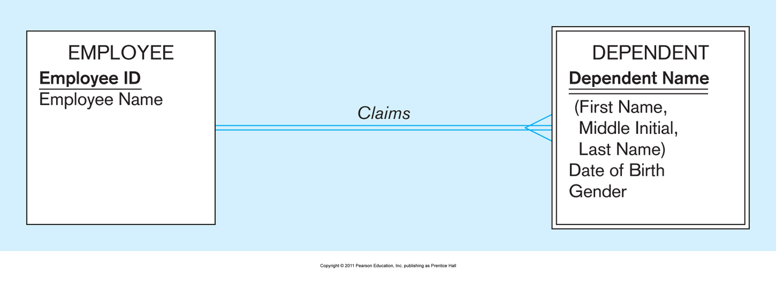
ANSWER:

- Translate the TEXTBOOK ERD Model to Relational Model

ANSWER:

6. (10 points) (H) ERD Model to TEXTBOOK ERD Model to Relational Model

- Translate this ERD Model to the TEXTBOOK ERD Model
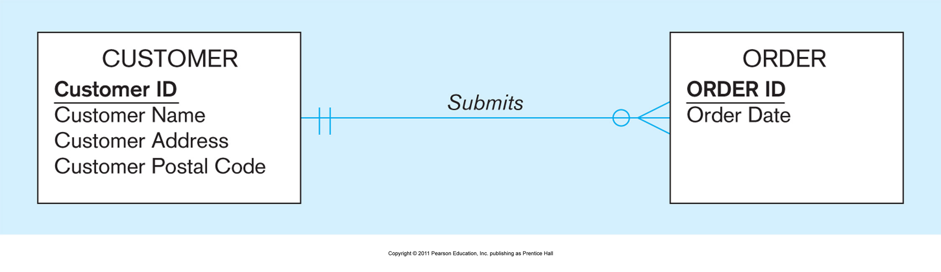
ANSWER:

- Translate the TEXTBOOK ERD Model to Relational Model

ANSWER:

7. (10 points) (H) ERD Model to TEXTBOOK ERD Model to Relational Model

- Translate this ERD Model to the TEXTBOOK ERD Model
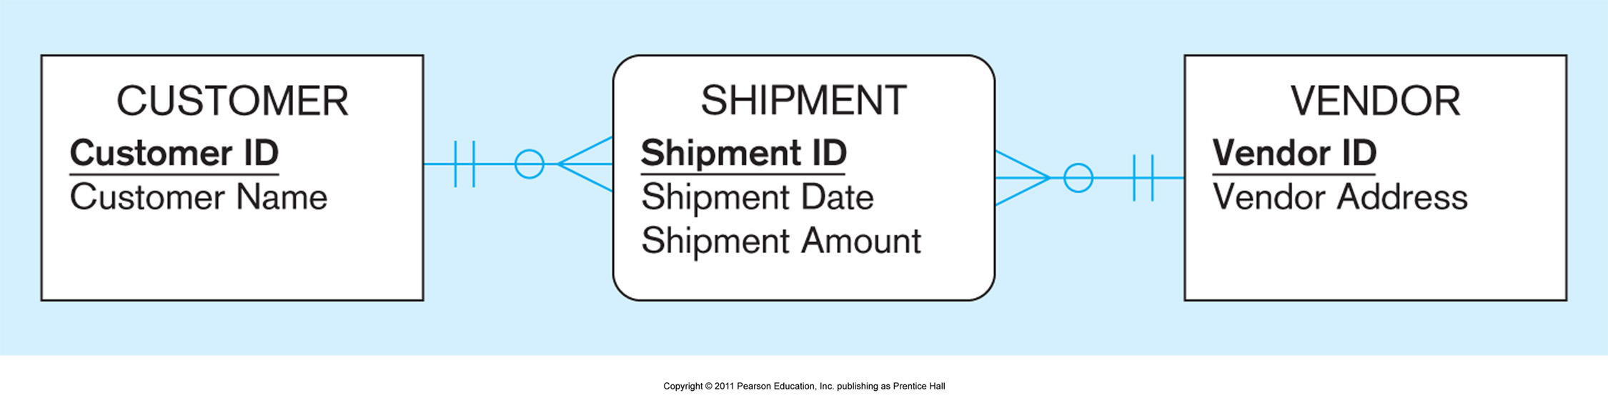
ANSWER:

- Translate the TEXTBOOK ERD Model to Relational Model

ANSWER:

BASED on LECTURE 5 NORMALIZATION

8. (10 points) (H)

Consider a Relation R with five attributes A, B, C, D, and E. The following dependencies are given:

AB → C,
BC → D,
CD → E,
DE → A.

 | A | B | C | D

1. List all keys for R. Do not list superkeys that are not a key.

2. Is R in 3NF? Briefly explain why.

3. Is R in BCNF? If yes, please explain why. Otherwise, decompose R into relations that are in BCNF.

ANSWER:

9. (10 points) (H)

R(A, B, C) with FD's

AB -> C,
C -> B

 | A | B | C

- In BCNF? Why or why not?

- In 3NF? Why or why not?

ANSWER:

10. (10 points) (H)

TABLE 4-5 below shows a Relation called Shipping Manifest for a shipping company. Your assignment is as follows:

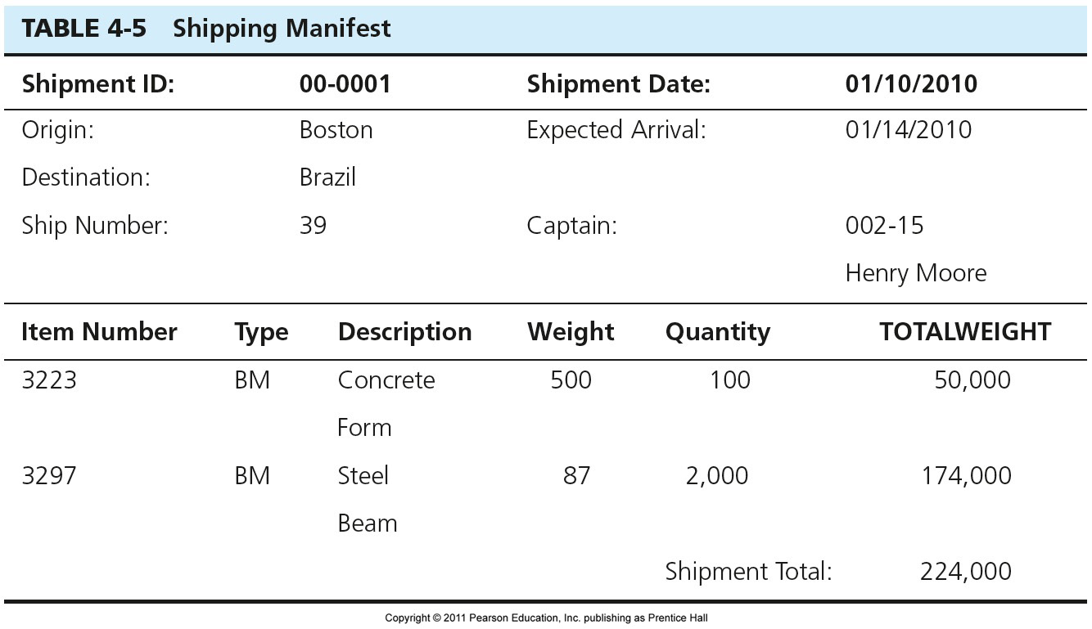

HINT:

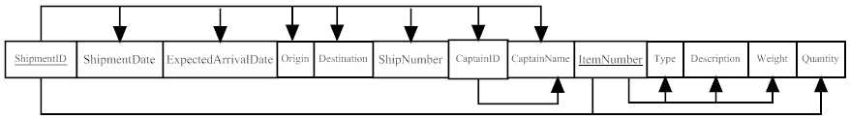

Normalize it.
a. Draw a Relational schema and diagram the functional dependencies in the Relation.

ANSWER:

b. In what normal form is this Relation?

ANSWER:

c. Decompose Shipping Manifest into a set of 3NF Relations.

ANSWER:

